DSA06 – DATA HANDLING AND VISUALIZATION
Sankey Diagram – Answers
R.No: 40 Reg. No: 192525102 Name: Yashika R
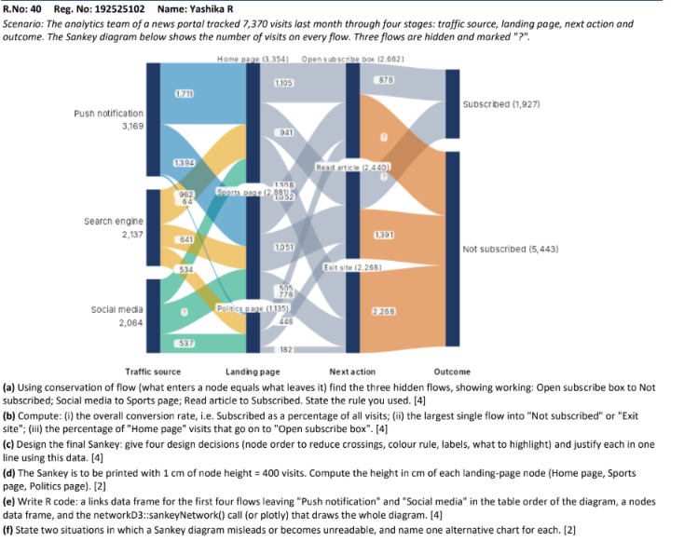

(a) Find the three hidden flows, showing working
Rule used: Conservation of flow — the total entering a node must equal the total leaving that node.
1. Open subscribe box → Not subscribed: Total entering Open subscribe box = 2,662 visits. The flow to Subscribed is 878 visits. Therefore, 2,662 − 878 = 1,784 visits.
2. Social media → Sports page: Total entering Sports page = 2,881 visits. Push notification → Sports page = 1,394 and Search engine → Sports page = 641. Therefore, 2,881 − 1,394 − 641 = 846 visits.
3. Read article → Subscribed: Total entering Read article = 2,440 visits. Read article → Not subscribed = 1,391 visits. Therefore, 2,440 − 1,391 = 1,049 visits.

(b) Calculations
(i) Overall conversion rate
Conversion rate = (Subscribed visits ÷ Total visits) × 100
= (1,927 ÷ 7,370) × 100 = 26.15% (approximately).
(ii) Largest single flow into “Not subscribed” or “Exit site”
The largest single flow is Exit site → Not subscribed = 2,268 visits. This is larger than the other flows into Not subscribed (1,784 and 1,391 visits).
(iii) Percentage of Home page visits that go to Open subscribe box
Home page → Open subscribe box = 1,105 visits; total Home page visits = 3,354.
Percentage = (1,105 ÷ 3,354) × 100 = 32.95% (approximately).

(c) Four design decisions for the final Sankey diagram
- Node order: Keep the stages in the natural order—Traffic source, Landing page, Next action, and Outcome—to make the user journey easy to follow.
- Colour rule: Use one consistent colour for each traffic source, or use neutral colours for flows and a distinct colour for the final outcome. Apply the same rule throughout.
- Labels: Show node totals and label important flows with visit counts. Place labels where they do not overlap; use a legend if colours represent categories.
- What to highlight: Highlight the Subscribed outcome and the largest loss flow, Exit site → Not subscribed (2,268 visits), because these are useful for evaluating conversion and drop-off.

(d) Height of each landing-page node
Scale: 1 cm represents 400 visits. Height = Number of visits ÷ 400.
Home page: 3,354 ÷ 400 = 8.385 cm ≈ 8.39 cm.
Sports page: 2,881 ÷ 400 = 7.2025 cm ≈ 7.20 cm.
Politics page: 1,135 ÷ 400 = 2.8375 cm ≈ 2.84 cm.

(e) R code to create a Sankey diagram
The following example uses networkD3. It includes the first four flows leaving Push notification and Social media in the order shown in the diagram, followed by the remaining source-to-landing flows so that the full first stage is represented.
# Install once if needed:
# install.packages("networkD3")
library(networkD3)
# Nodes are numbered from 0 in networkD3 links
nodes <- data.frame(
name = c("Push notification", "Search engine", "Social media",
"Home page", "Sports page", "Politics page",
"Open subscribe box", "Read article", "Exit site",
"Subscribed", "Not subscribed")
)
# Source and target use zero-based node indices.
# First four flows are listed first, in diagram order.
links <- data.frame(
source = c(0, 0, 0, 1, 2, 2, 2, 1, 1),
target = c(3, 4, 5, 3, 3, 4, 5, 4, 5),
value = c(1711, 1394, 64, 962, 681, 846, 537, 641, 534)
)
# Add landing-page-to-next-action and next-action-to-outcome
# flows to complete the diagram.
links2 <- data.frame(
source = c(3, 3, 3, 4, 4, 4, 5, 5, 5,
6, 6, 7, 7, 8),
target = c(6, 7, 8, 6, 7, 8, 6, 7, 8,
9, 10, 9, 10, 10),
value = c(1105, 941, 1308, 941, 1051, 889,
616, 448, 71, 878, 1784, 1049, 1391, 2268)
)
all_links <- rbind(links, links2)
sankeyNetwork(
Links = all_links,
Nodes = nodes,
Source = "source",
Target = "target",
Value = "value",
NodeID = "name",
fontSize = 12,
nodeWidth = 20
)
Note: The diagram image is low-resolution, so some intermediate flow labels are difficult to read. Verify the intermediate links in the R code against the original high-resolution diagram before submitting; the calculations in (a), (b), and (d) use the clearly readable totals and flows.

(f) Two situations where a Sankey diagram can mislead or become unreadable
1. When there are too many nodes and crossing flows, the diagram becomes cluttered and difficult to trace. Alternative: use a table or a heat map.
2. When flows have very different sizes, small flows may be almost invisible beside large flows. Alternative: use a bar chart with a suitable scale.

